# European airspace – EU visitors learn about ATM challenges and ambitions

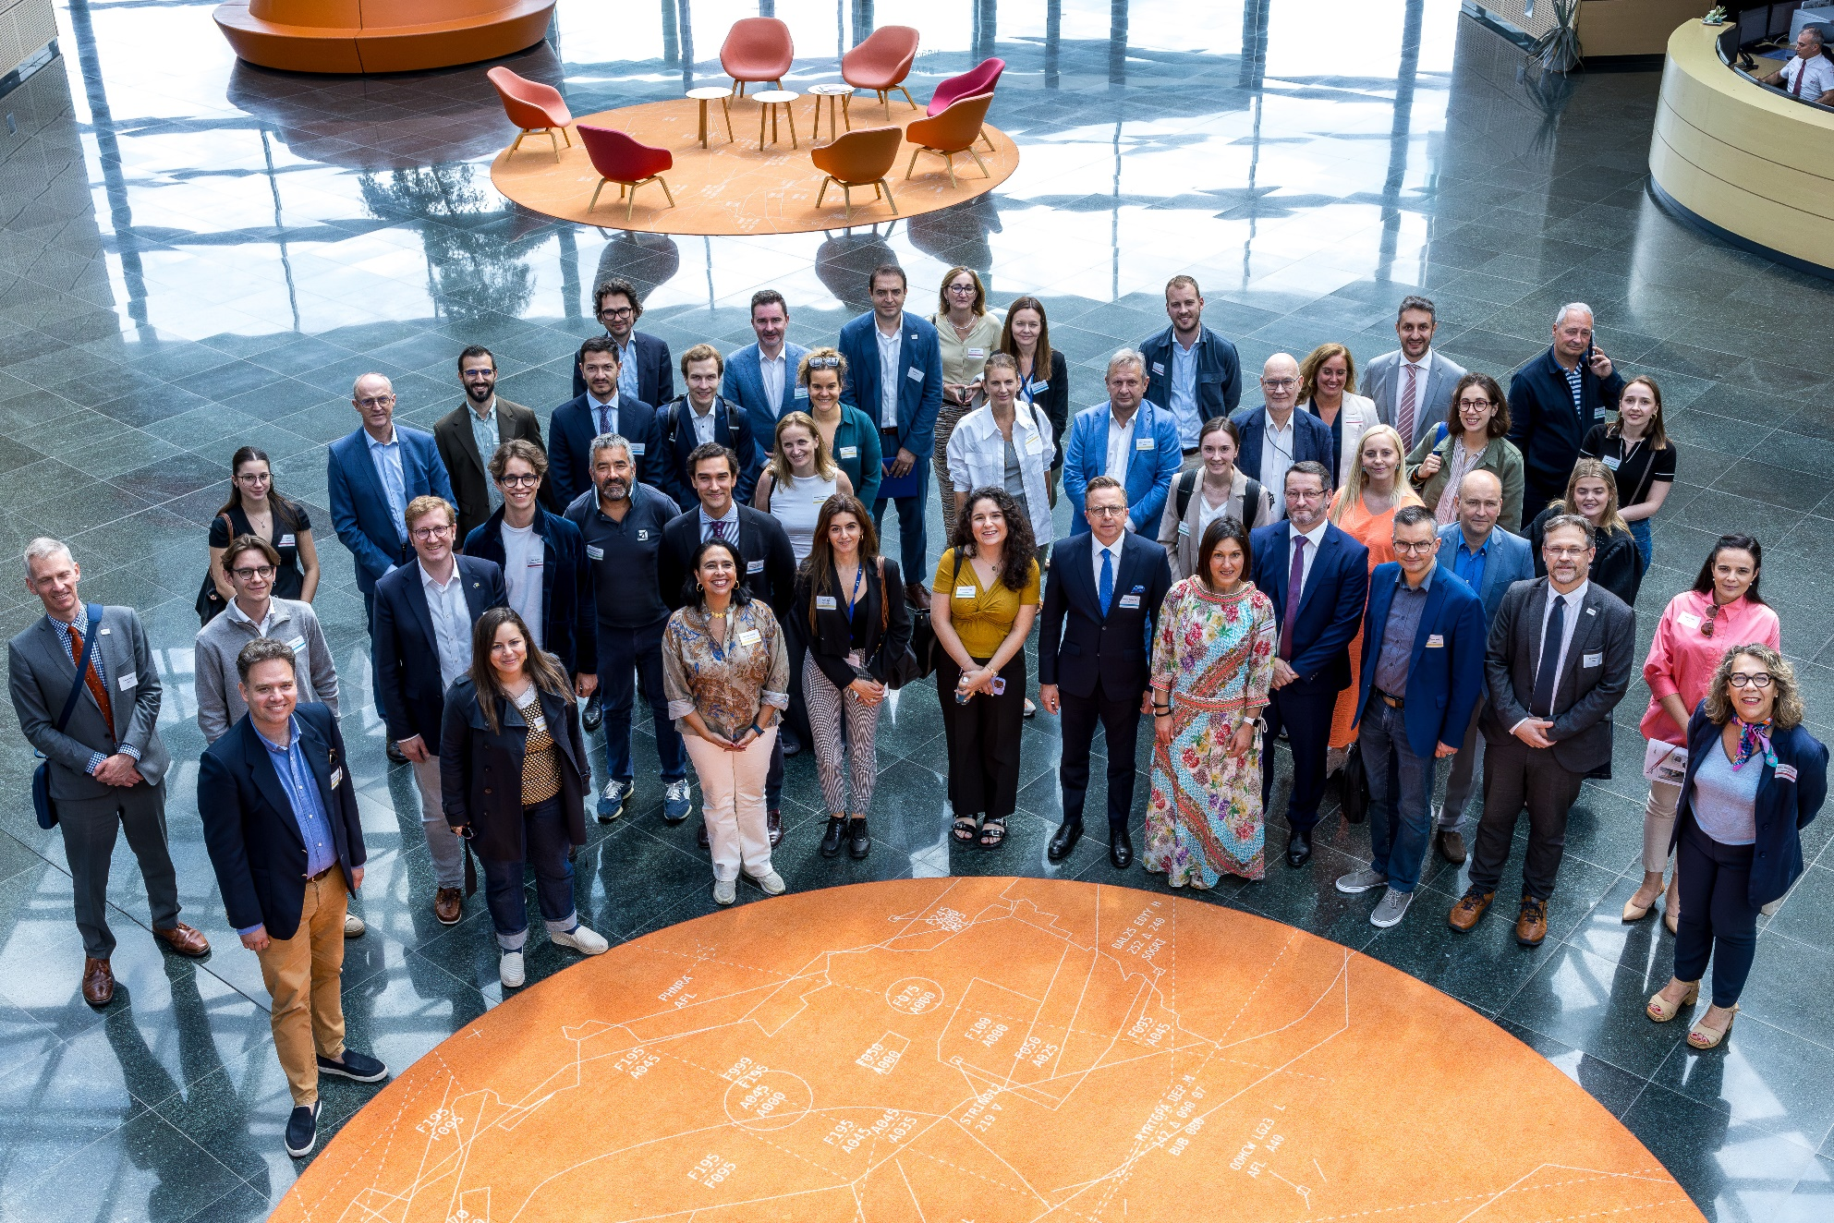

**Brussels, 16 July 2025 – Yesterday afternoon, Members of the European Parliament’s Transport Committee, European Commission officials and other EU policymakers visited the Belgian air traffic control centre of skeyes near Brussels Airport to learn about** **how air traffic management (ATM) works in practice.**

**As air traffic across Europe approaches pre-pandemic levels, Europe’s air navigation services providers (ANSPs) face the challenge of safely guiding aircraft across increasingly crowded skies during the busiest time of the year. It was therefore timely for the visitors to see these complex operations at first hand. They were invited as guests of skeyes, the Belgian ANSP, and the Civil Air Navigation Services Organisation (CANSO), which represents the European ATM industry.**

Over 30 tour guests visited:

* the air traffic control tower serving Brussels Airport
* the air traffic control centre (CANAC 2), which houses both the civil and military air traffic controllers
* the Digital Tower Test Centre, a prototype for the digital control centre currently being set up by skeyes in Namur
* SkeyDrone, which offers services to integrate drones into airspace

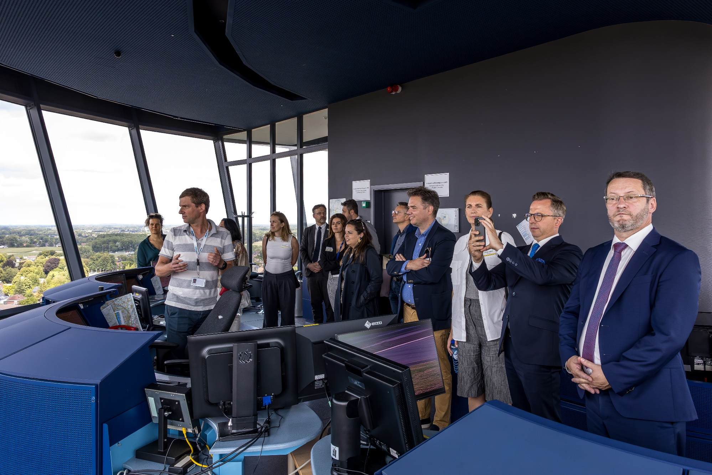

The hosts also informed the visitors about the ATM industry’s plans to digitalise and automate systems and processes, the recruitment of new air traffic controllers and how ANSPs can facilitate environmentally optimal routing.

skeyes CEO, Johan Decuyper said: *“Collaboration is key to progress. At skeyes, we actively share our know-how with partners across Europe to help build a stronger, more connected, and future-ready airspace. This collaborative spirit goes hand in hand with our continued investment in innovation – from advanced ATM technologies to digital towers and drone integration. skeyes is widely recognised for its commitment to punctuality – even in an airspace environment marked by turbulent times. These achievements reflect the strength of our strategy and the commitment of our people. Together, we are not only managing today’s skies – we are actively shaping the future of aviation.”*

Mario Kunovec-Varga, CEO of Croatia Control and Vice-Chair of CANSO’s EC3 (CEO Committee) said: *“Safety is always CANSO’s number one priority, but it was also important to show our guests how ANSPs intend to provide more airspace capacity to match continuously growing air traffic demand and accommodate the unplanned and unexpected levels of regional traffic growth. Our industry calls for EU support to create the right regulatory environment for this transition, with enabling capacity as the critically important focus.”*

**About CANSO**

CANSO – the Civil Air Navigation Services Organisation – is the global voice of the air traffic management (ATM) industry and is shaping our future skies. Our members support over 90% of the world’s air traffic and include air navigation service providers, airspace users and operators, manufacturers and aviation industry suppliers. We raise the bar on global ATM performance by connecting the industry to share knowledge, expertise and innovation.

**About skeyes**

skeyes ensures the safety and efficiency of air traffic in Belgium 24/7. The skeyes air traffic controllers manage over 3,000 aircraft every day, which makes up over a million flight movements per year. The autonomous public company is active at the heart of Europe, in one of the busiest and most complex sections of airspace of the continent. skeyes is active at Brussels Airport and at the airports of Antwerp, Charleroi, Kortrijk, Liège and Ostend. Thanks to its CANAC 2 control centre skeyes manages the flight movements above Belgium and a part of Luxembourg up to an altitude of 7,500 metres. The company relies on its nearly 900 experienced staff members who are at the service of their customers: airline companies, airports, the aviation sector and the authorities. skeyes also develops innovating services regarding drones and contributes to a sustainable future of the aviation sector, among other things with respect to the environment.

skeyes is a member of FABEC, a joint airspace block (Belgium, Luxembourg, the Netherlands, Germany, France and Switzerland) with the aim of improving air navigation efficiency in the heart of Europe in the framework of the Single European Sky.

**Media contacts**

**CANSO**

Johnny Pring, Manager Europe Policy and Advocacy   
Email: [johnny.pring@canso.org](mailto:johnny.pring@canso.org)   
Phone: +32 493 53 61 24

**skeyes**

Audrey Dorigo, Spokesperson skeyes

Email: [Audrey.Dorigo@skeyes.be](mailto:Audrey.Dorigo@skeyes.be)

Phone: +32 475 77 84 03

*Photos by Omar Havana for Elio Germani*